Max Heap Sort
A Max Heap is a complete binary tree in which the value of every parent node is greater than or equal to the values of its children. Therefore, the largest element is always present at the root. A Max Heap is commonly used in Heap Sort and priority queues.
In Heap Sort, first a Max Heap is created from the given elements. Then the largest element (root) is swapped with the last element, and the remaining elements are heapified again. This process is repeated until the entire array is sorted.
PROGRAM: C code
#include <stdio.h>
void heapify(int a[], int n, int i)
{
int largest = i;
int left = 2 * i + 1;
int right = 2 * i + 2;
int temp;

if (left < n && a[left] > a[largest])
largest = left;

if (right < n && a[right] > a[largest])
largest = right;

if (largest != i)
{
temp = a[i];
a[i] = a[largest];
a[largest] = temp;

heapify(a, n, largest);
}
}

int main()
{
int a[50], n, i, temp;

printf("Enter number of elements: ");
scanf("%d", &n);

printf("Enter elements:\n");
for (i = 0; i < n; i++)
scanf("%d", &a[i]);

// Create Max Heap
for (i = n / 2 - 1; i >= 0; i--)
heapify(a, n, i);

// Heap Sort
for (i = n - 1; i > 0; i--)
{
temp = a[0];
a[0] = a[i];
a[i] = temp;

heapify(a, i, 0);
}

printf("Sorted array:\n");
for (i = 0; i < n; i++)
printf("%d ", a[i]);

return 0;
}
OUTPUT:
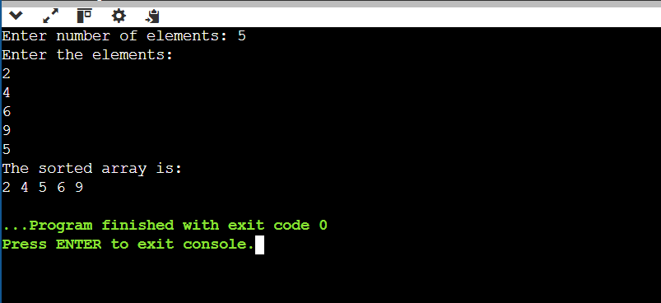

Conclusion:
Case | Time Complexity
Best Case | O(n log n)
Average Case | O(n log n)
Worst Case | O(n log n)
Space Complexity | O(1)

